Automotive Foundation Technician  Program | Day 1 Requirements | 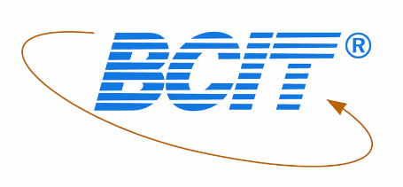

Welcome to BCIT, first before the first day of school please have these items ready to use. You will require textbooks, CSA approved steel toed work boots and CSA approved safety glasses (no tinted lenses). We will be completing an orientation on the first day of school so be prepared to be there for most of the day.

To access and purchase textbooks go on to the BCIT bookstore, select the Burnaby campus and scroll down to “generate your book list” and click on “add courses to your list”. Closer to the middle/end of August the drop down menu should give you an option to select “fall winter 2019” next select “Auto-Automotive. Then select Foundation. Next select “FT-Erho” or “FT-Jit” and click on “generate book list”. All the required books will appear. (Note you have a choice of a paper or digital copy of the Advanced Electricity and Electronics) please only choose 1. This book is only available for 5 months electronically.

To purchase work boots and safety glasses best to go to Mark’s work warehouse. Indicate you are a student to receive a 10% discount.

The second day of school will be a full day and will be from that day forward.

If you have any questions please don’t hesitate to contact me. The best way to connect is via email.
Greg_erho@bcit.ca

